**Personal Password Manager**

**Introduction:**

This application is designed to manage and interact with stored passwords. It provides functionalities to list, view, add, update, and delete passwords.

**1. List Passwords**

Displays all stored passwords in a table or list format.

* **Functionality:**
  + Fetch and display a list of passwords from the backend.
  + Include actions for viewing, updating, and deleting passwords.

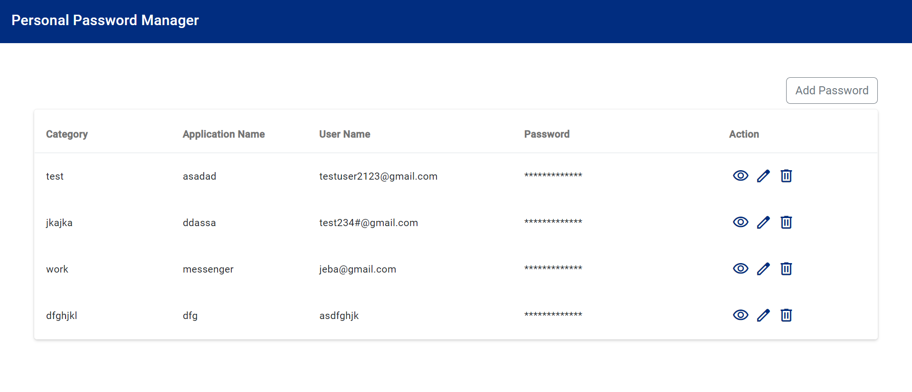

1. Navigate to <http://localhost:4200/passwords>
2. Password Summary page listing the password details will be open

**2. View Password**

Displays the details of a specific password with an option to decrypt and view the password.

* **Functionality:**
  + Fetch and display password details.
  + Provide an option to decrypt the password and show it
* Steps :
* Click on the eye icon under the action column to view the password details

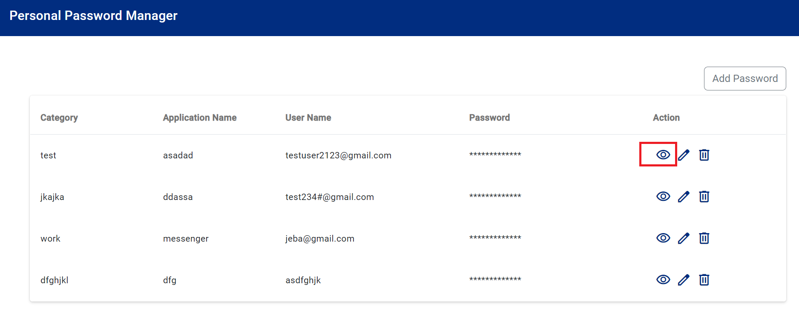

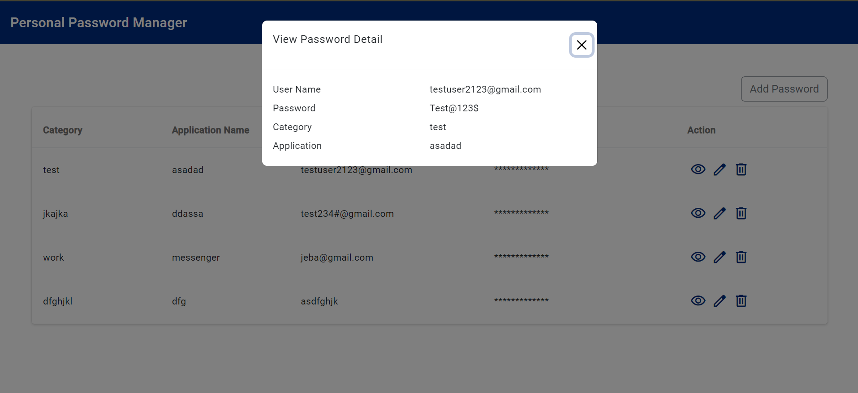

**3. Add Password**

Provides a form to add a new password entry.

* **Functionality:**
  + Include fields for service, username, and password.
  + Validate the form and handle submission.
* Steps :
* Click add password button in the summary page.
* Add Password page will be open fill all the details such and App, Category, User name and password
* Click submit to submit the details

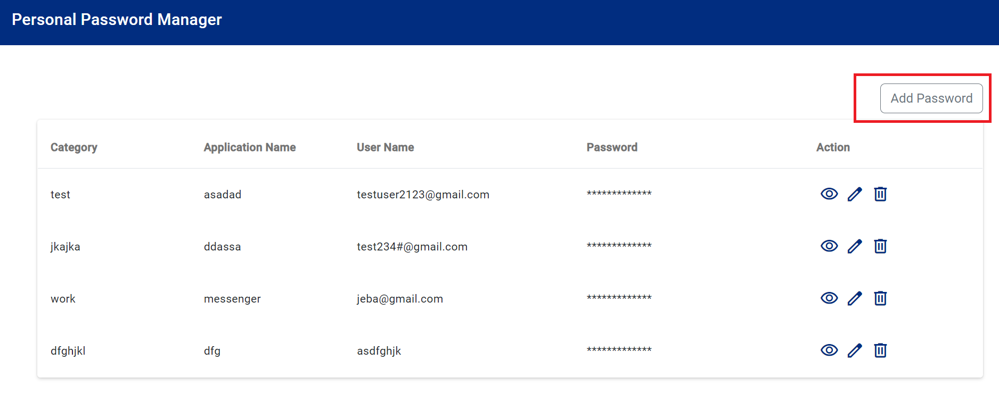

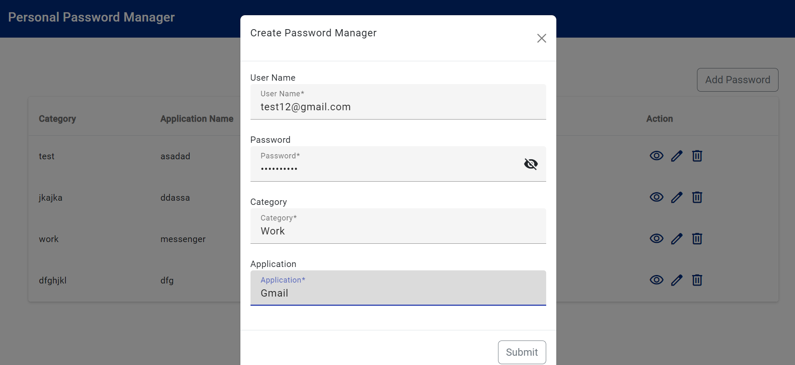

**4. Update Password**

Allows updating an existing password with the option to view it in decrypted mode before editing.

* **Functionality:**
  + Fetch existing password details.
  + Allow editing of the password details.
  + Button is included to toggle between showing and hiding the decrypted password.
* Steps :
* Click on the edit icon under the ‘Action’ column of password that need to be edited
* Form with all the existing detail of the password will be opened.
* Change the necessary details that need to be changed and click on submit.
* The data will be updated in the list view .

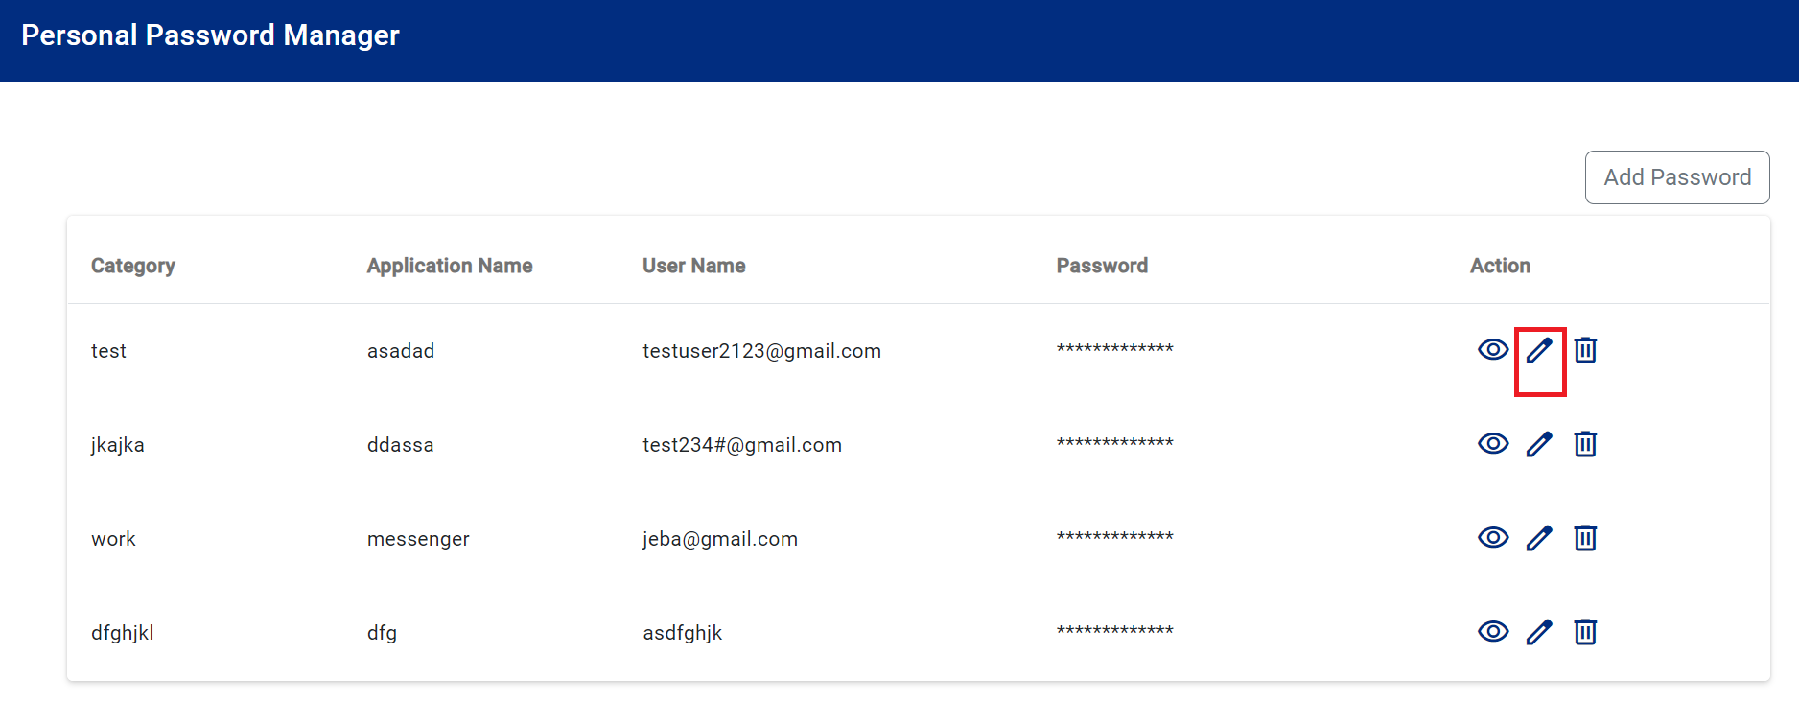

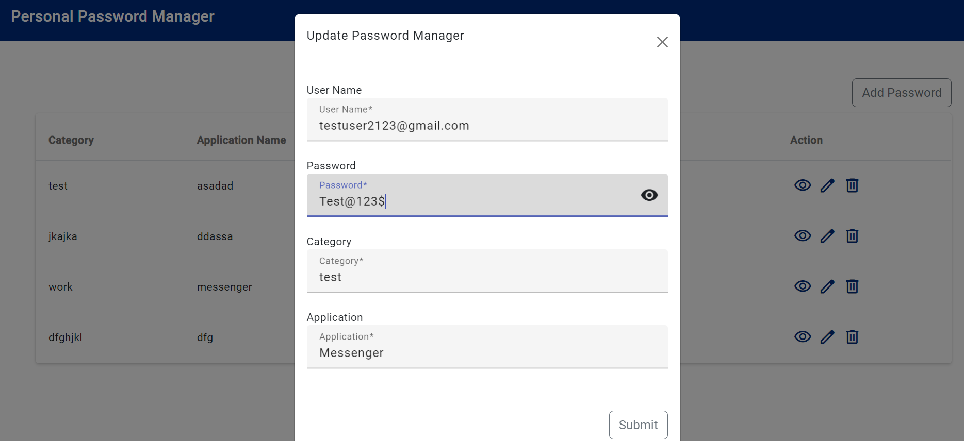

**5. Delete Password**

Removes a password from the list.

* **Functionality:**
  + Confirm deletion before proceeding.
  + Send a request to delete the password from the backend.
* Steps:
* Click on the delete icon under the ‘Action’ column of password that need to be deleted

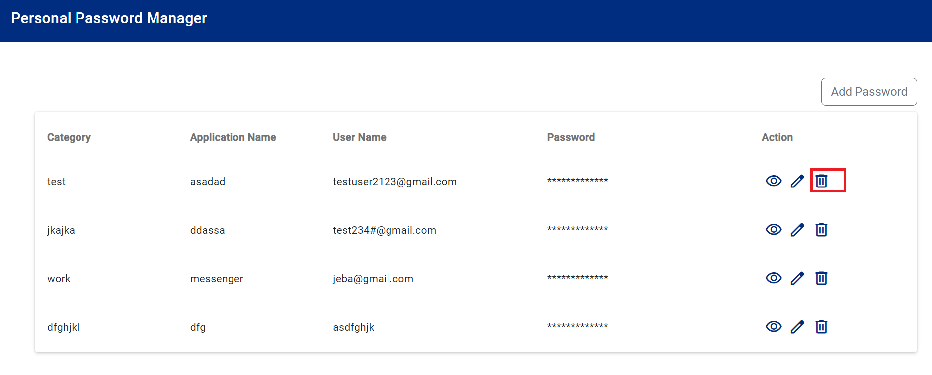

* Confirmation message will be asked for deletion of the record.

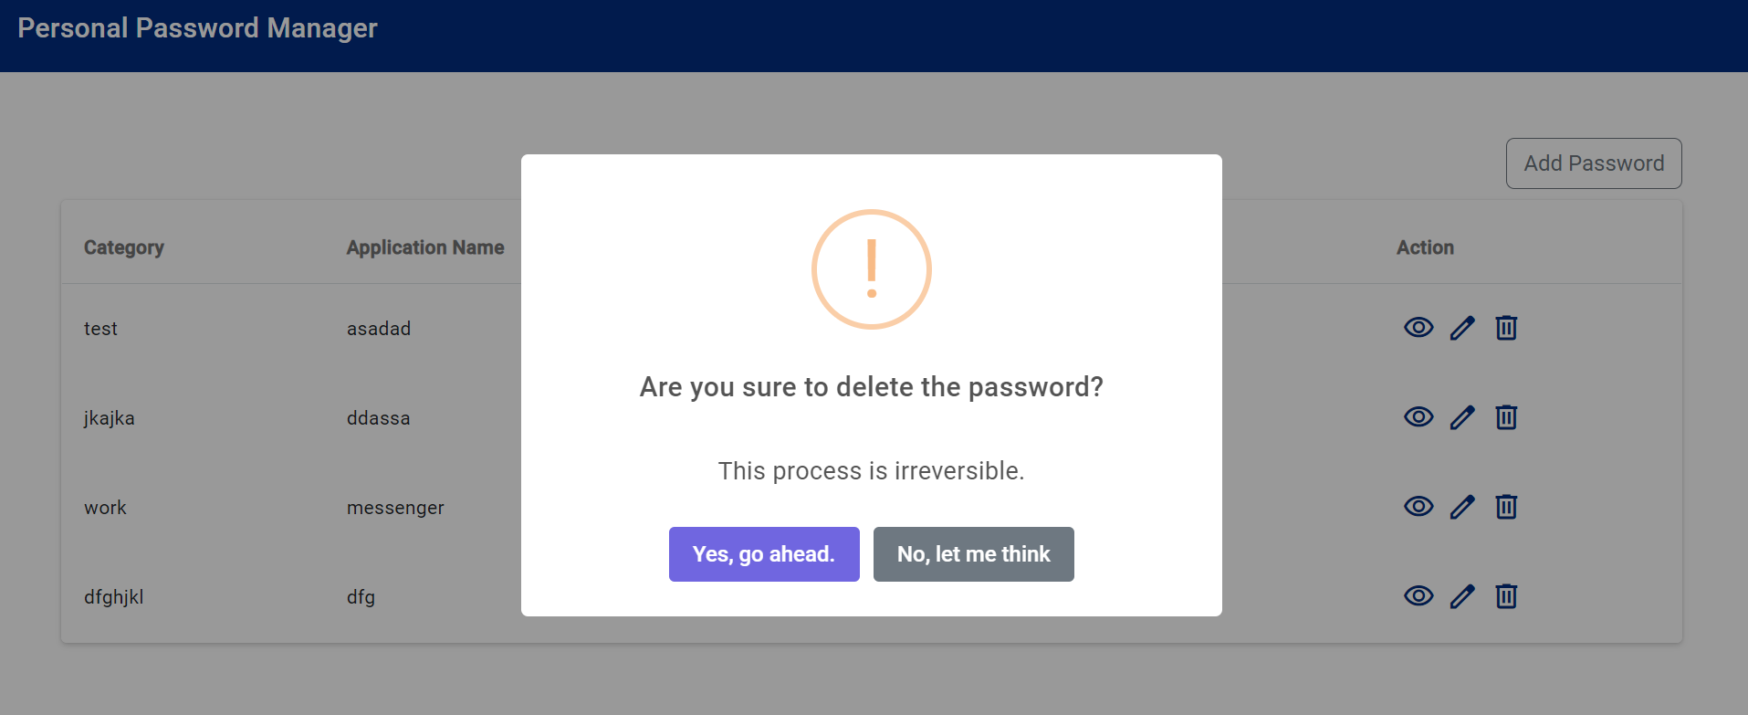

* Click on Yes, Go ahead to delete the record or click on No to cancel deletion.